6701223036

Maheswari Adelia Kirana

D3SI-46-01

1. Commit v1.0

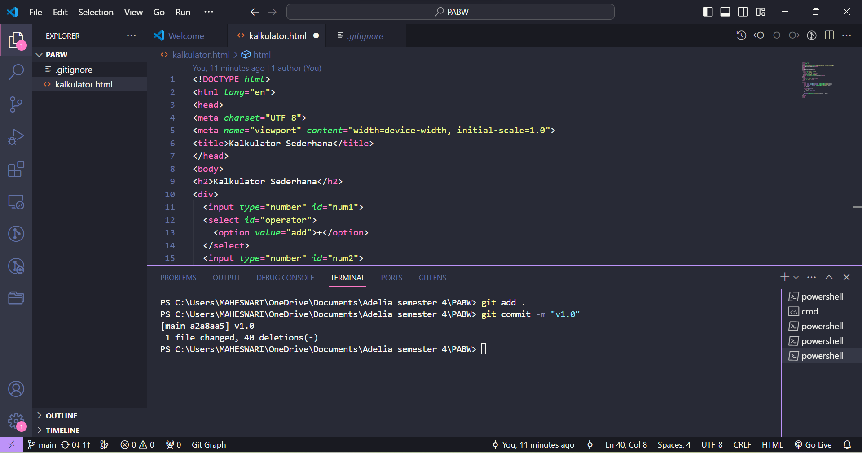

1. Commit v1.1

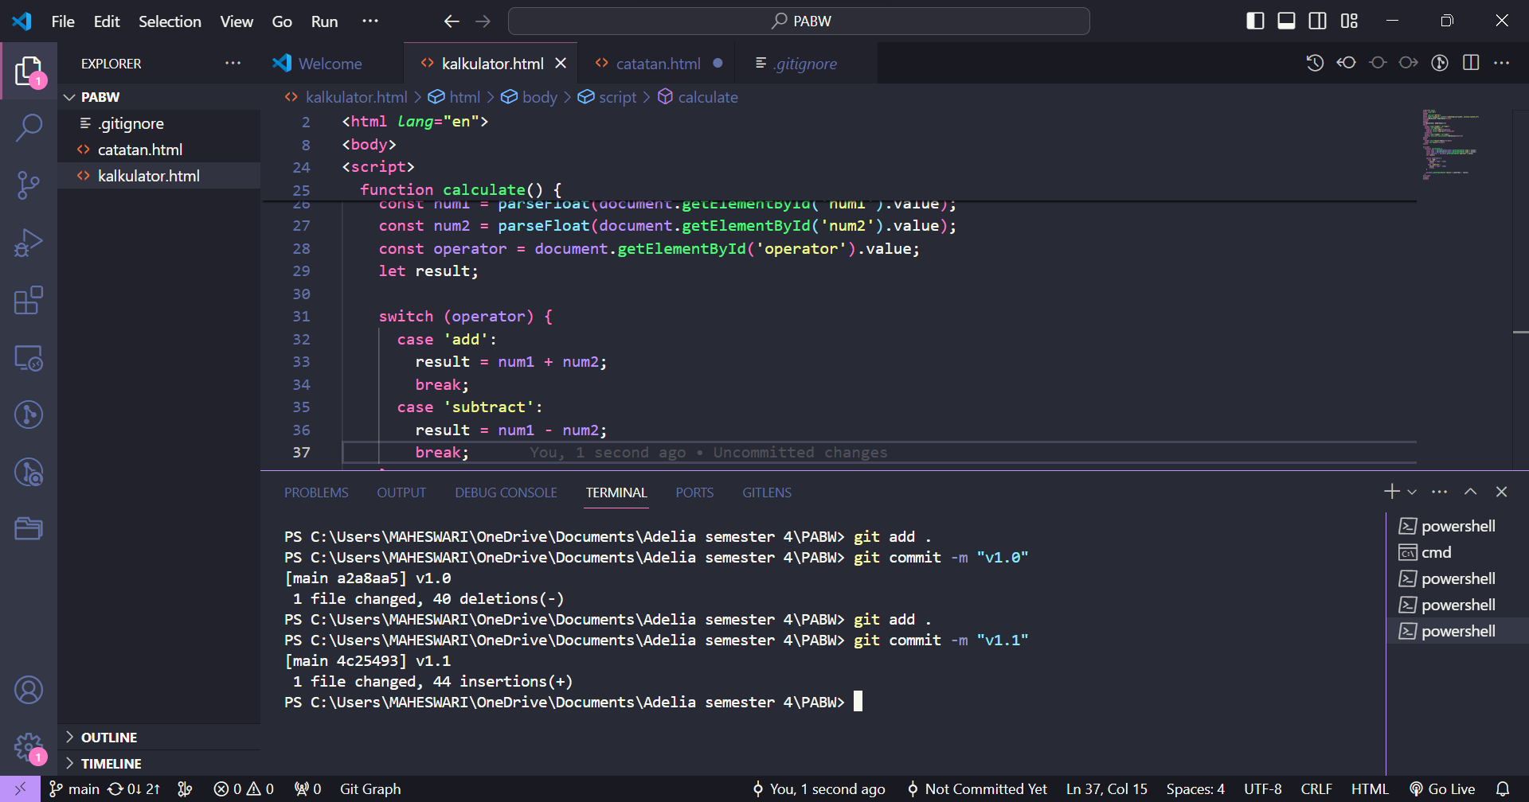

1. Commit v1.2

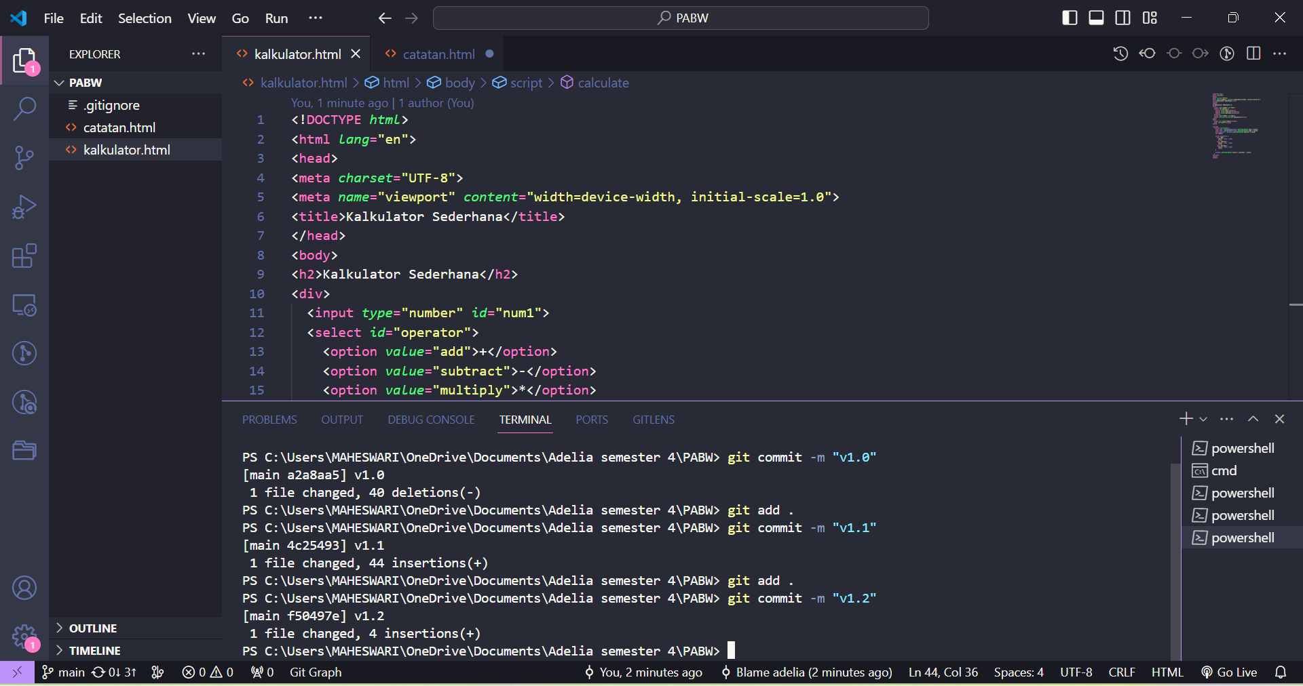

1. Commit v1.3

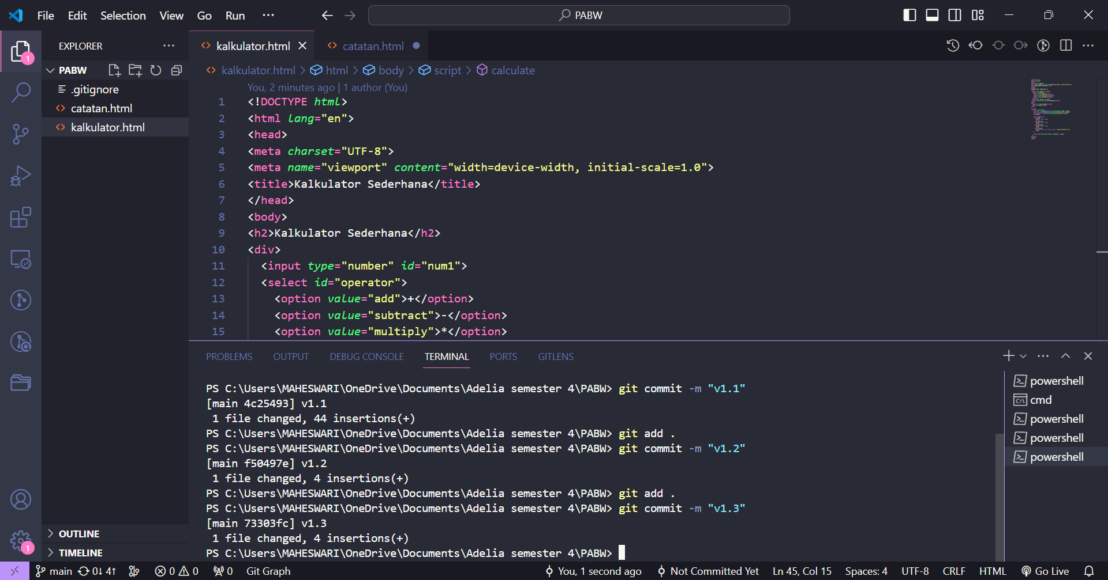

1. Commit v1.4

